JavaScript Applications Course

Documentation for “Food Manager” Project
Team “Peach”
Team Members:
Oleg Vasilev
Stoyan Mihaylov
Georgi Yolovski
Ilian Ivanov
Hristo Manchev
- Project purpose:

  - Personal Daily Food Manager
  - Save what food you eat every today.
  - Keep tracks of your food consuption.
  - Manage your food limits and nutrition values.
  - Organize what and how much you eat.
  - Manage a database with different kinds of food types.

- Food Manager Class Diagram

Some Classes and Modules

  - Nutrition.js
  - Food.js
  - User.js
  - Meal.js
  - DBManager.js
  - DayMeal.js
  - FoodManager.js
  - RenderClosure.js

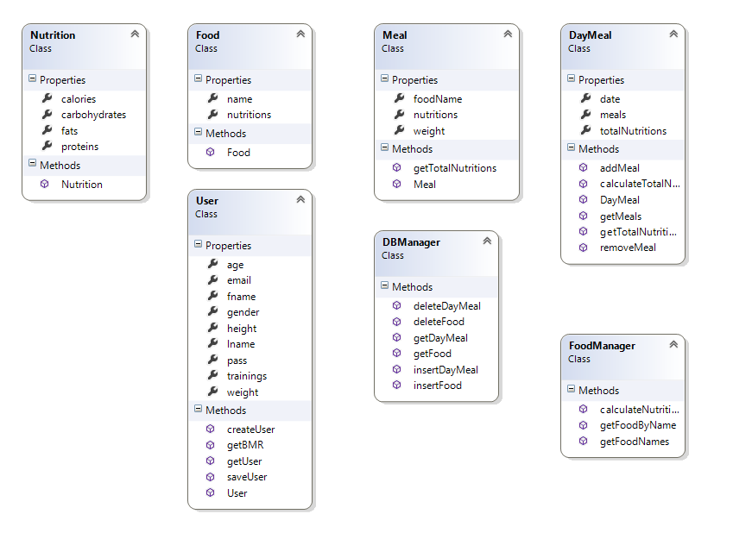

- Food Manager SVN Repository

http://food-manager.googlecode.com/svn/trunk/

- Additional Information

  - Responsive Web Design
  - Unit Tests

